LEXINGTON S Designed Sofa

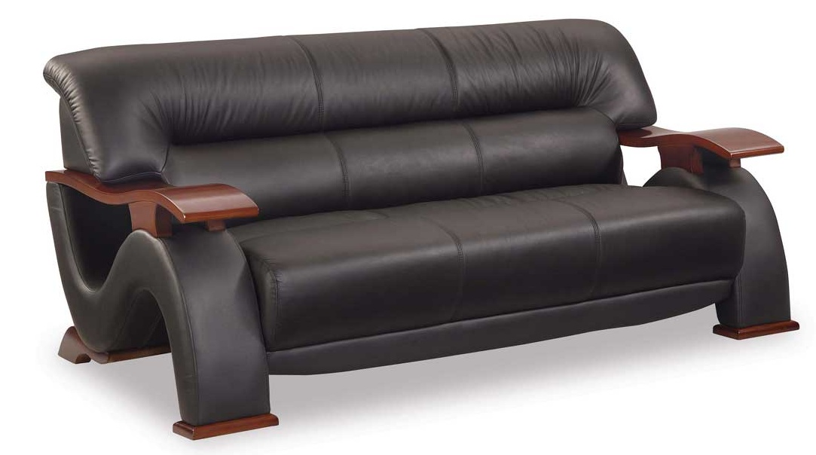

|  |
| --- |
| **DESCRIPTION** |
| The S shaped sofa, produced by LEXINGTON Sofa, presents a sleek, low profile design that is both functional and comfortable. The extra-wide and deep relaxed form on top and extra long legs on bottom provides stability for the sofa. The new S shaped design makes this sofa a hybrid version of the entire Sofa Industry. |

|  |  |  |
| --- | --- | --- |
| **Price** | **2100$** | |
| **Dimensions** | **H** x **W** x **L** | **28in x 32in x 66in** |
| **Features** | **Comfortable for three but 5 people can also sit at once with air tight pressure and shock absorbers enable it to have long healthy life.** | |
| **Finished** | **Mussed Flat Leather** | |
| **Available in** | **Brown , Red and Dark Blue** | |